**Unit 2: Job hunting**

**Key Vocabulary:**

**ПОЛУЧЕНИЕ РАБОТЫ**

|  |  |
| --- | --- |
| ad или advert (сокращённо от advertisement) | реклама, объявление |
| application form | заявление |
| appointment | встреча |
| CV (сокращённо от curriculum vitae) | резюме |
| job description | описание работы |
| interview | интервью |
| job offer или offer of employment | предложение работы |
| qualifications | квалификации |

|  |  |
| --- | --- |
| to apply for a job | подать заявление на работу |
| to accept an offer | принять предложение |
| to reject an offer или to turn down an offer | отказаться от предложения |
| to hire | нанимать |

|  |  |
| --- | --- |
| job | работа |
| career | карьера |
| part-time | неполная занятость |
| full-time | полная занятость |
| shift work | работа по графику |
| temporary | временный |
| contract | контракт |
| permanent | постоянный |
| starting date | дата начала работы |
| notice period | срок для уведомления об увольнении (срок, за которой сотрудник должен уведомить работодателя об уходе с занимаемой должности) |

**ЗАРПЛАТА И ЛЬГОТЫ**

|  |  |
| --- | --- |
| bonus | бонус |
| car allowance | компенсация за использование автомобиля |
| company car | служебная машина |
| health insurance | страхование здоровья |
| holiday pay | отпускные |
| holiday entitlement | право на отпуск |
| maternity leave | отпуск по уходу за ребёнком (для матери) |
| overtime | сверхурочные часы; сверхурочное время |
| paternity leave | отпуск по уходу за ребёнком (для отца) |
| part-time education | обучение с неполной нагрузкой |
| pension scheme или pension plan | пенсионный план |
| promotion | повышение; продвижение по службе |
| salary | жалованье; оклад |
| salary increase | повышение зарплаты |
| sick pay | пособие по болезни; выплата по больничному листу |
| staff restaurant | столовая для сотрудников |
| training scheme | план обучения |
| travel expenses | расходы на проезд |
| wages | зарплата |
| working conditions | условия труда |
| working hours | часы работы |

**ТИПЫ РАБОТНИКОВ**

|  |  |
| --- | --- |
| owner | владелец |
| managing director | исполнительный директор |
| director | директор |
| manager | управляющий, заведующий; директор |
| boss | босс, начальник |
| colleague | коллега |
| trainee | стажёр, практикант |
| apprentice | ученик |
| volunteer | доброволец |

**УХОД С РАБОТЫ**

|  |  |
| --- | --- |
| to fire | увольнять |
| to get the sack | быть уволенным(разговорное) |
| to resign | уходить в отставку |
| to retire | уходить на пенсию |

|  |  |
| --- | --- |
| leaving date | дата ухода |
| redundant | уволенный по сокращению штатов |
| redundancy | сокращение штатов |
| redundancy pay | выходное пособие (выплачиваемое при увольнении по сокращению штатов) |
| retirement age | пенсионный возраст |

**ДРУГИЕ ПОЛЕЗНЫЕ СЛОВА**

|  |  |
| --- | --- |
| apprenticeship | обучение; ученичество |
| department | отдел |
| experience | опыт |
| factory | фабрика |
| fire drill | учебные занятия пожарной команды |
| health and safety | здоровье и безопасность |
| internship | интернатура |
| meeting | встреча |
| office | офис |
| rate of pay | оклад |
| reception | приёмная |
| security | охрана |
| strike | забастовка |
| switchboard | распределительный щит |
| timekeeping | пунктуальность |
| trade union | профсоюз |
| training course | курс обучения |
| work | работа |
| work experience | опыт работы |

|  |  |
| --- | --- |
| to go on strike | бастовать |
| to be off sick | отсутсвовать по болезни |

|  |  |
| --- | --- |
| self-employed | работающий не по найму; работающий на себя |
| unemployed | безработный |
| retired | вышедший на пенсию |

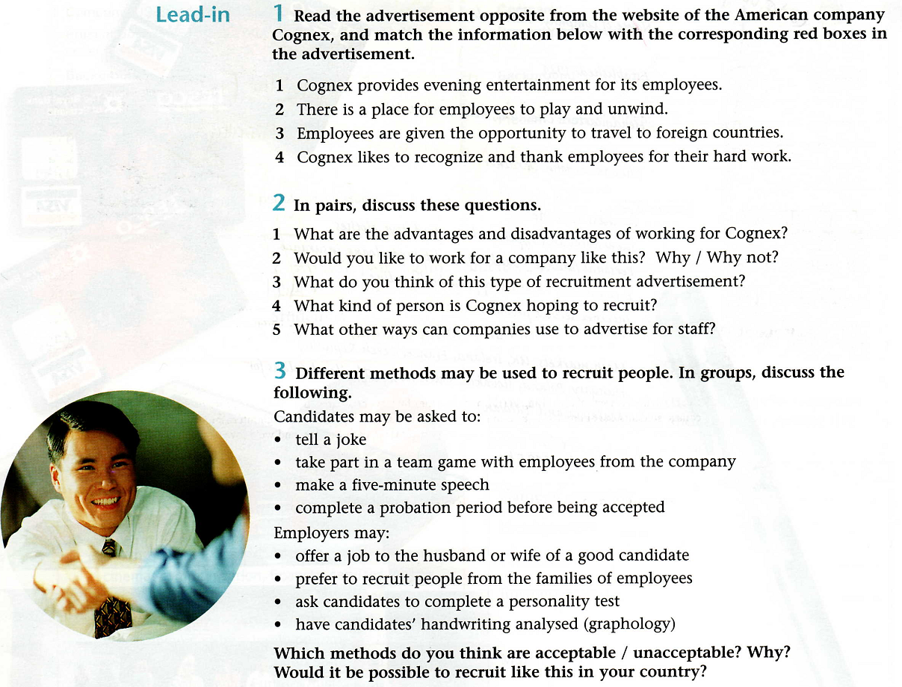



**READ THE TEXT**

***Прочитать и перевести рекламный текст по теме.***

**Text Vocabulary:**confident, to rely, cunning, accomplishment, to propel, white-collar jobs, brainteasers, to evaluate, intagible, flexible, to face, a hire, to slash, a layer, a pace, to shift, to bring around, a sence, a limitation, a decision, a choice, drug use, harassment, traits, to predict

**Fit For Hiring? It`s Mind Over Matter**

By Judith H.Dobrzynski

NEW YORK – Members of America`s professional and managerial classes have always left college confident of at least one thing: they had taken their last test. From here on, they could rely on charm, cunning* and\or a record of accomplishment to propel them up the corporate ladder.

But that`s ot necessarily true any longer. A growing number of companies, from General Motors Corp to American Express Co., are no longer satisfied with traditional job interviews. Instead, they are requiring applicants for many white-collar jobs – from top executives down – to submit to a series of paper-and-pencil tests, role-playing exercises, simulated decision – making exercises and brainteasers*. Others put candidates through a long series of interviews by psychologists or trained interviewers.

The tests are not about mathematics or grammar, nor about any of the basic technical skills for which many production, sales and clerical workers have long been tested. Rather, employers want to evaluate candidates on intangible* qualities: Is she creative entrepreneurial? Can he lead and coach ? Is he flexible and capable of learning? Does she have passion and a sense of urgency? How will he function under pressure? Most important, will the potential recruit fit the corporate culture?

These tests, which can take from an hour to two days, are all part of a broader trend. ‘Companies are getting much more careful about hiring ,’ said Paul R. Ray Jr., chairman of the Association of Executive Search Consultants.

Ten years ago, candidates could win a top job with the right look and the right answers to questions such as ‘Why do you want this job?’. Now, many are having to face questions and exercises intended to learn how they get things done.

They may, for example, have to describe in great detail not one career accomplishment but many – so that patterns of behavior emerge. They may face questions such as ‘Who is the best friend like?. The answers, psychologists say, reveal much about a candidate`s management style and about himself or herself.

The reason for the interrogations is clear: many hires* work out badly. About 35 percent of recently hired senior executives are judged failures, according to the Center for Creative Leadership in Greensboro, North Carolina, which surveyed nearly 500 chief executives.

The cost of bringing the wrong person on board is sometimes huge. Searching and training can cost from $ 5000 for a lower-level manager to $250.000 for a top executive. Years of corporate downsizing, a trend that has slashed* layers of management, has also increased the potential damage that one bad executive can do. With the pace of change accelerating in markets and technology, companies want to know how an executive will perform, nor just how he or she has performed.

‘Years ago, employers looked for experience – has a candidate done this before?’ said Harold P. Weinstein, executive vice-president of Caliper, a personnel testing and consulting firm in Princeton, New Jersey. ‘But having experience a job does not guarantee that you can do it in a different environment.

At this point, most companies have not shifted to this practice. Some do not see the need to remain unconvinced that such testing is worth the cost. But human-resource specialists say anecdotal* evidence suggest that white-collar testing is growing in popularity. What has brought so many employers around to testing is a sense of the limitations in the usual job interview. With so little information on which to base a decision, ‘most people hire people they like, rather than the most competent person,’ said, that ‘most decision makers make their hiring decisions in the first five minutes of an interview and spend the rest of the time rationalizing their choice.

Besides, with advice on how to land a better job about as common as a еут-dollar bill, many people are learning to play the interview game.

Even companies that have not started extensive testing have toughened their hiring practices. Many now do background checks, for example, looking for signs of drug use, violence or sexual harassment. But the more comprehensive testing aims and organization, attention to detail and management style; personality traits* and motivations that behavioral scientist say predict performance.

New York Times

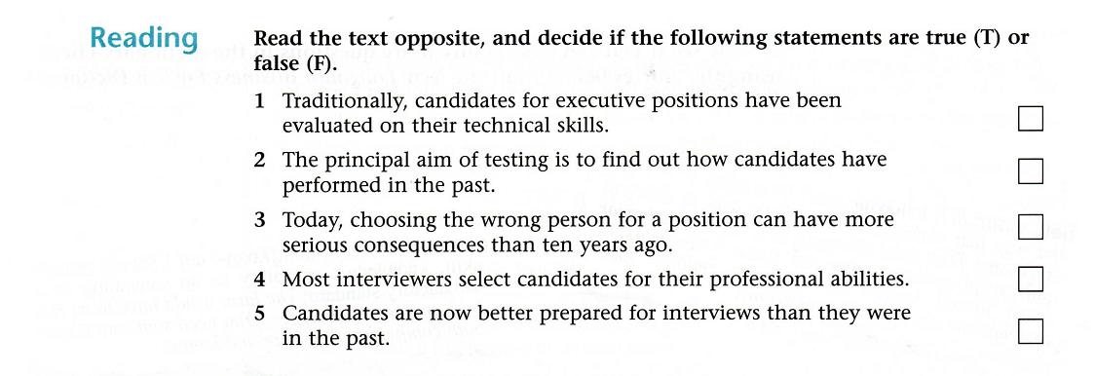

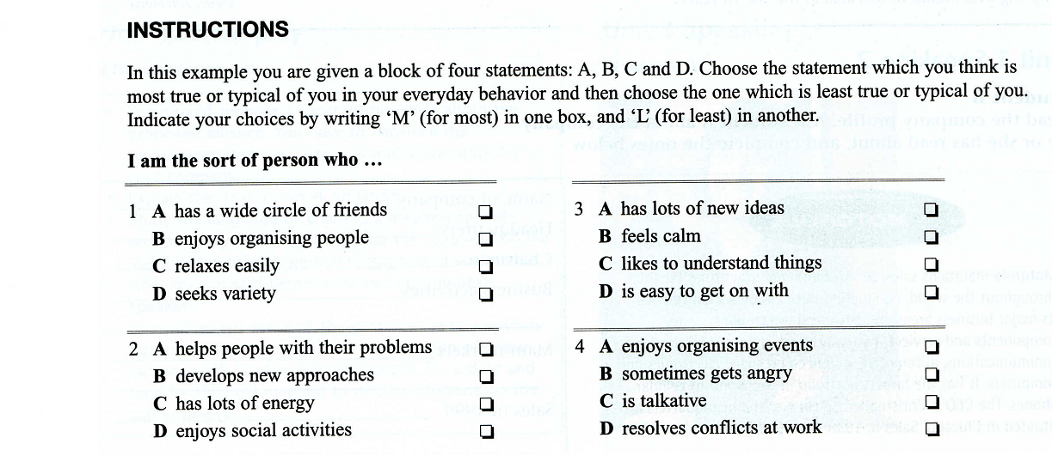

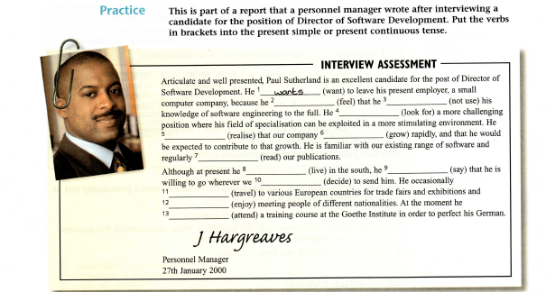

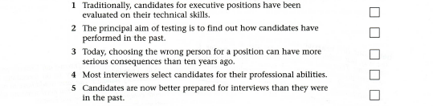

**СРС № 1 – *Контрольно-тренировочные упражнения.***

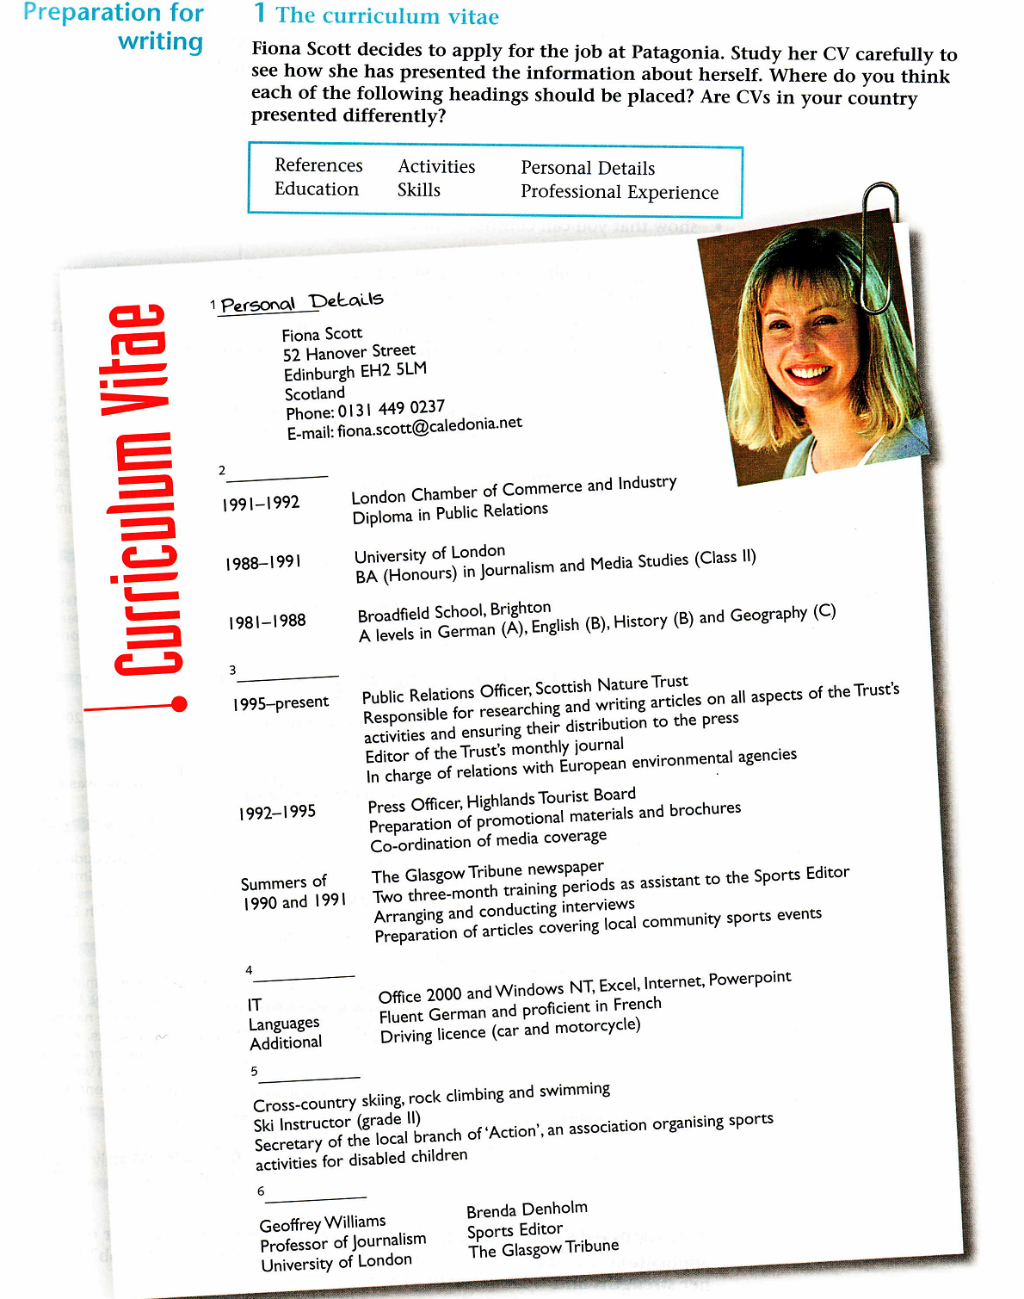

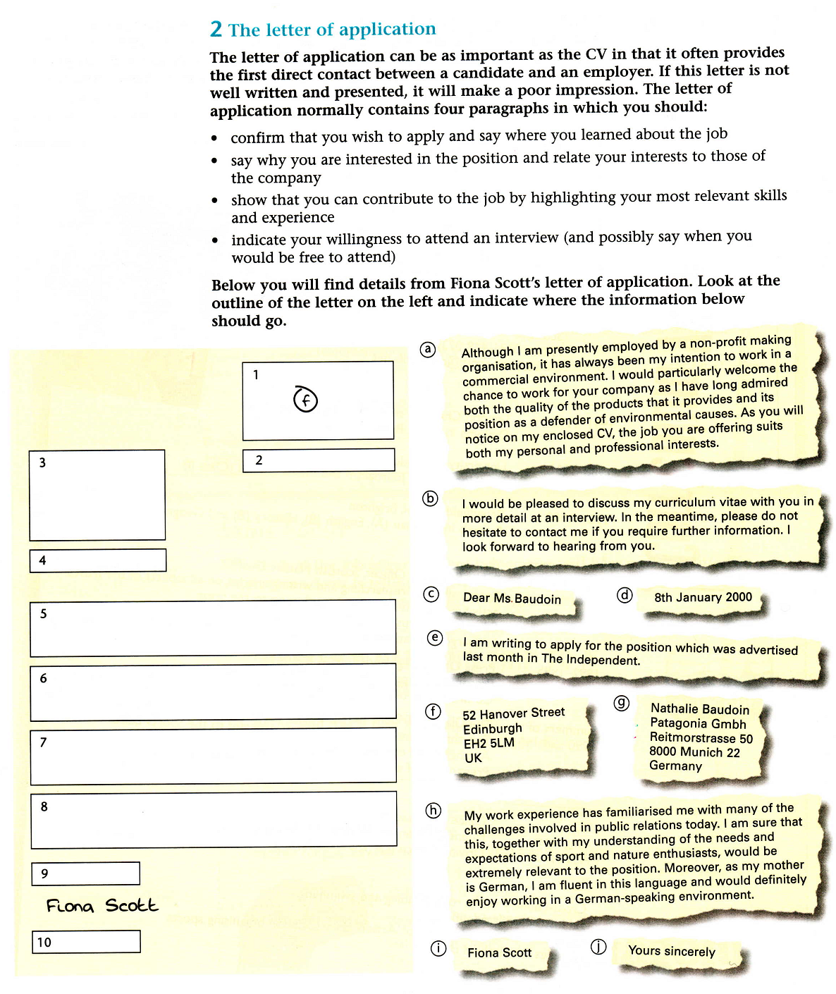

**CРС №2-**

**А) *Составить автобиографию на английском языке.***

**Sample Autobiography Topic List**

1. What is your full name?
2. When were you born?
3. What are your parent's names? Are they still together, alive? What/how is/was your relation with your mother, your father?
4. Do you have any siblings, what are their names?
5. What is your relationship with your siblings?
6. Are you the eldest, middle, youngest child?
7. Are you right or left handed?
8. Do you wear glasses/contacts?

**Key phrases:**

1. I was bornin…
2. I was an active (quiet, knowledge-loving, shy, curious, etc.) child.
3. My childhood dream was…
4. My earliest memory is…
5. I am grateful to my parents (teachers/ friends), because…
6. My role-model was…
7. My life time dream is…
8. The most memorable day in my life was…
9. The phrase that I will never forget was…
10. If only one of my dreams could come true, I would wish for…

Feel free to use this example of autobiography for students and take the effortless steps described above to complete an A-level memoir with ease.

**Model:**

My name is… my English name is David. I am applying for the vacancy of the JUNIOR NETWORK PROGRAMMER which you advertised on the Employment Web Page of April 23rd.

I hold a bachelor's degree with a major in Economics which was awarded to me by Fu-Jen University in Taipei in 1997. Although I am a novice in the workforce, I am qualified for this position according to the requirements which were described in your advertisement. First, I have good command of English, because my university minor subject was English. Moreover, my TEFL test scores were 600. These two facts provide the evidence that I have a quite adequate command of English to work in an international company like yours.

Second, although computer science is not my major subject at the university, the courses I have taken like Data Management, C-Language and Calculus have prepared me for software programming in the field of finance and investment. My grades in these three courses were all above 80. In addition to my computer programming, I was employed at the university's computer center where I assisted the instructors in teaching students how to search web sites on the internet, and how to send e-mail messages by using Outlook software. Moreover, I helped students design their web page by familiarizing them with both PowerPoint and Front Page software.

Third, I was not only active in the university but also a participant in a 1998 International Conference of Web Technology Development in Taiwan. The experience brought me into contact with professional societies and helped me improve my social skills when interacting and communicating with professional people. This experience also taught me how to work with people efficiently.

As far as my private life is concerned, I am from a middle-class nuclear family which is composed of four members: my parents, my younger sister and I. My father is a businessman who deals with international trade. My mother used to work in a bank, but she retired recently. My sister studies nursing and she is going to work in a hospital. My family life is calm and steady. My parents love their children and hold great expectation that their children can establish their own career independently and live a happy life. Fortunately, up to now I have not disappointed them. I have completed my required military service as an airforce sergeant. My hobbies include movies, music and sports. I am an enthusiastic, initiative and interesting person although I can be straightforward and not very prudent in complicated situations. However, I learn from experience quickly.

I can confidently say that I am ready for my future. But I am looking for a good opportunity in which I can make a contribution to the welfare of the company which I will work for. Along with this experience, I hope to develop myself to keep pace with the changes of the era in my profession.

**СРС № 3-**

*А) Составить резюме на английском языке.*

**Личные данные – PERSONAL INFORMATION**

**цель – JOB OBJECTIVE**

**образование – EDUCATION**

**опыт работы – EXPERIENCE**

**навыки – SKILLS**

**дополнительные сведения, увлечения – EXTRACURRICULAR ACTIVITIES**

**рекомендации – REFERENCES**

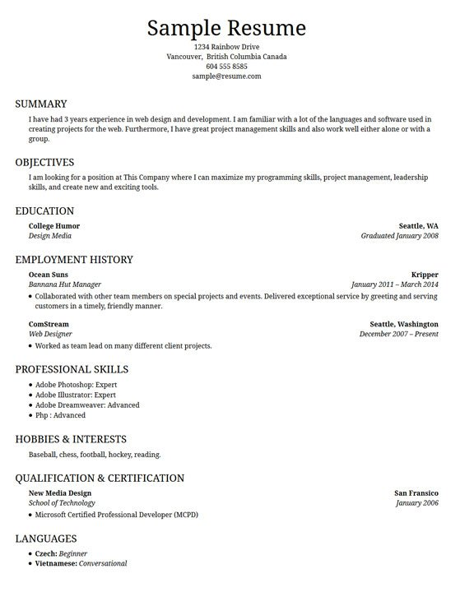

**СРС № 4 -*Оформить бланк заявления об устройстве на работу***

*Model:*

Subject: (logical to recipient!) Inquiry about software engineering position after completion of M.S. in computer engineering

December 12, 20XY

Mr. Robert Burns

President, Template Division

MEGATEK Corporation

9845 Technical Way

Arlington, VA 22207

burns@megatek.com

Dear Mr. Burns:

Via online research in Hokies4Hire through Career Services at Virginia Tech, I learned of MEGATEK. Next May I will complete my master of science in computer engineering. From my research on your web site, I believe there would be a good fit between my skills and interests and your needs. I am interested in a software engineering position upon completion of my degree.

As a graduate student, I am one of six members on a software development team in which we are writing a computer-aided aircraft design program for NASA. My responsibilities include designing, coding, and testing of a graphical portion of the program which requires the use of ZX-WWG for graphics input and output. I have a strong background in CAD, software development, and engineering, and believe that these skills would benefit the designing and manufacturing aspects of template software. Enclosed is my resume with further background information.

My qualifications equip me to make a contribution to the project areas in which your division of MEGATEK is expanding efforts. I would appreciate the opportunity to discuss a position with you, and will contact you in a week or ten days to answer any questions you may have and to see if you need any other information from me. Thank you for your consideration.

Sincerely,

Morgan Stevens

123 Ascot Lane

Blacksburg, VA 24060

(540) 555-2556

[mstevens@vt.edu](mailto:mstevens@vt.edu)

**CPC – 5 - *Подготовить глоссарий по теме на английском языке.***

***Glossary-* Match the term with its definition**

A **shareholder** or **stockholder** is an [individual](https://en.wikipedia.org/wiki/Individual" \o "Individual) or institution (including a [corporation](https://en.wikipedia.org/wiki/Corporation" \o "Corporation)) that legally owns a [share](https://en.wikipedia.org/wiki/Share_(finance)" \o "Share (finance)) of [stock](https://en.wikipedia.org/wiki/Stock" \o "Stock) in a [public](https://en.wikipedia.org/wiki/Public_company" \o "Public company) or [private corporation](https://en.wikipedia.org/wiki/Private_corporation" \o "Private corporation). **Shareholders** are the owners of a [limited company](https://en.wikipedia.org/wiki/Limited_company" \o "Limited company). They buy shares which represent part ownership of a company.

**Management** in [businesses](http://en.wikipedia.org/wiki/Businesses" \o "Businesses) and [organizations](http://en.wikipedia.org/wiki/Organizations" \o "Organizations) is the function that coordinates the efforts of people to accomplish goals and [objectives](http://en.wikipedia.org/wiki/Goal" \o "Goal) using available resources efficiently and effectively.

An **accountant** is a practitioner of [accounting](http://en.wikipedia.org/wiki/Accounting" \o "Accounting) or accountancy, which is the measurement, disclosure or provision of assurance about financial information that helps managers, investors, tax authorities and others make decisions about allocating resources.

A **consumer** is a person or organization, that uses [economic services](http://en.wikipedia.org/wiki/Service_(economics)" \o "Service (economics)) or [commodities](http://en.wikipedia.org/wiki/Commodity" \o "Commodity).

**To improve** is to grow better; to [advance](http://en.academic.ru/dic.nsf/cide/2781/advance) or make [progress](http://en.academic.ru/dic.nsf/cide/139659/progress)in what is [desirable](http://en.academic.ru/dic.nsf/cide/48167/desirable).

**To reduce** is to bring down the size, quantity, quality, value or intensity of something; to [diminish](http://en.wiktionary.org/wiki/diminish" \o "diminish), to [lower](http://en.wiktionary.org/wiki/lower" \o "lower), to [impair](http://en.wiktionary.org/wiki/impair" \o "impair).

**Employment** is a relationship between two [parties](http://en.wikipedia.org/wiki/Party_(law)" \o "Party (law)), usually based on a [contract](http://en.wikipedia.org/wiki/Employment_contract" \o "Employment contract), one being the [employer](http://en.wikipedia.org/wiki/Employer" \o "Employer) and the other being the [employee](http://en.wikipedia.org/wiki/Employee" \o "Employee).

**Salary** is a fixed amount of money or compensation paid to an employee by an employer in return for work performed. Salary is commonly paid in fixed intervals, for example, monthly payments of one-twelfth of the annual salary.

A **skill** is the [learned](http://en.wikipedia.org/wiki/Learning" \o "Learning) ability to carry out a task with pre-determined results often within a given amount of [time](http://en.wikipedia.org/wiki/Time" \o "Time), [energy](http://en.wikipedia.org/wiki/Energy" \o "Energy). In other words the abilities that one possesses. Skills can often be divided into [domain](http://en.wikipedia.org/wiki/Departmentalization" \o "Departmentalization)-general and domain-specific skills. For example, in the domain of work, some general skills would include [time management](http://en.wikipedia.org/wiki/Time_management" \o "Time management), [teamwork](http://en.wikipedia.org/wiki/Teamwork" \o "Teamwork) and [leadership](http://en.wikipedia.org/wiki/Leadership" \o "Leadership), [self](http://en.wikipedia.org/wiki/Self" \o "Self) [motivation](http://en.wikipedia.org/wiki/Motivation" \o "Motivation) and others, whereas domain-specific skills would be useful only for a certain [job](http://en.wikipedia.org/wiki/Job_(role)" \o "Job (role)). Skill usually requires certain environmental stimuli and situations to assess the level of skill being shown and used.

**Finance** is a study which figures out how people, businesses and groups make and use money. It can mean:Thinking about [money](http://simple.wikipedia.org/wiki/Money" \o "Money). Thinking about how to control money to make profit. Studying how to take chances in projects that make money. As a verb, "to finance" is to make money for [business](http://simple.wikipedia.org/wiki/Business" \o "Business).

**Recruitment** synonymous with "hiring" in American English, refers to the overall process of attracting, selecting and appointing suitable candidates for [jobs](http://en.wikipedia.org/wiki/Job" \o "Job) within an organization, either permanent or temporary, unpaid positions, such as voluntary roles or training programmes. Managers, human resource generalists and recruitment specialists may recruit in-house, while public-sector employment agencies, commercial recruitment agencies, or specialist search consultancies may undertake parts of the process. Internet-based technologies to support all aspects of recruitment has become widespread.

A **résumé**  is a document used by persons to present their backgrounds and skills. Résumés can be used for a variety of reasons, but most often they are used to secure new employment.  A typical résumé contains a summary of relevant job [experience](http://en.wikipedia.org/wiki/Experience" \o "Experience) and [education](http://en.wikipedia.org/wiki/Education" \o "Education). The résumé is usually one of the first items, along with a [cover letter](http://en.wikipedia.org/wiki/Cover_letter" \o "Cover letter) and sometimes an application for employment, which a potential [employer](http://en.wikipedia.org/wiki/Employer" \o "Employer) sees regarding the job seeker and is typically used to [screen](http://en.wikipedia.org/wiki/Screening_(economics)" \o "Screening (economics)) applicants, often followed by an [interview](http://en.wikipedia.org/wiki/Interview" \o "Interview). The résumé is comparable to a [curriculum vitae](http://en.wikipedia.org/wiki/Curriculum_vitae" \o "Curriculum vitae) (CV) in many countries. However, it is substantially shorter than a CV in [English Canada](http://en.wikipedia.org/wiki/English_Canada" \o "English Canada), the [U.S.](http://en.wikipedia.org/wiki/United_States" \o "United States) and [Australia](http://en.wikipedia.org/wiki/Australia" \o "Australia).

A **cover letter**, **covering letter**, **motivation letter**, **motivational letter** or a **letter of motivation** is a [letter](http://en.wikipedia.org/wiki/Letter_(message)" \o "Letter (message)) of introduction attached to, or accompanying another [document](http://en.wikipedia.org/wiki/Document" \o "Document) such as a [résumé](http://en.wikipedia.org/wiki/R%C3%A9sum%C3%A9" \o "Résumé) or [curriculum vitae](http://en.wikipedia.org/wiki/Curriculum_vitae" \o "Curriculum vitae).

**Work experience** is any [experience](http://en.wikipedia.org/wiki/Experience" \o "Experience) that a person gains while working in a specific field or occupation, but the expression is widely used to mean a type of [volunteer](http://en.wikipedia.org/wiki/Volunteer" \o "Volunteer) work that is commonly intended for young people — often [students](http://en.wikipedia.org/wiki/Students" \o "Students) — to get a feel for professional working environments. The [American](http://en.wikipedia.org/wiki/American_English" \o "American English) equivalent term is [internship](http://en.wikipedia.org/wiki/Internship" \o "Internship).

**Work activity** is the process of creating, delegating and tracking the progress of multiple tasks to completion.

**Education** in its general sense is a form of [learning](http://en.wikipedia.org/wiki/Learning" \o "Learning) in which the [knowledge](http://en.wikipedia.org/wiki/Knowledge" \o "Knowledge), [skills](http://en.wikipedia.org/wiki/Skills" \o "Skills), [values](http://en.wikipedia.org/wiki/Values" \o "Values), [beliefs](http://en.wikipedia.org/wiki/Belief" \o "Belief) and [habits](http://en.wikipedia.org/wiki/Habit_(psychology)" \o "Habit (psychology)) of a group of people are transferred from one generation to the next through storytelling, discussion, teaching, training, or research. Education may also include informal transmission of such information from one human being to another.

**Innovation** is a new idea, more effective device or process. Innovation can be viewed as the application of better solutions that meet new requirements, inarticulated needs, or existing market needs.This is accomplished through more effective [products](http://en.wikipedia.org/wiki/Product_(business)" \o "Product (business)), [processes](http://en.wikipedia.org/wiki/Procedure_(term)" \o "Procedure (term)), [services](http://en.wikipedia.org/wiki/Service_(economics)" \o "Service (economics)), [technologies](http://en.wikipedia.org/wiki/Technologies" \o "Technologies), or [ideas](http://en.wikipedia.org/wiki/Idea" \o "Idea) that are readily available to [markets](http://en.wikipedia.org/wiki/Market_(economics)" \o "Market (economics)), [governments](http://en.wikipedia.org/wiki/Government" \o "Government) and [society](http://en.wikipedia.org/wiki/Society" \o "Society).